1. Show all owner information.
2. .
3. Show all OwnerName and OwnerEmail which OwnerType is ‘Corporation’.
4. Show PropertyID and ServiceDate for all services have HoursWorked more than 4.
5. Show PropertyID and ServiceDate for all services have HoursWorked between 4 and 6.
6. Count how many services have HoursWorked more than 4.
7. Count how many distinct ExperienceLevel in EMPLOYEE table.
8. Show all employees with CellPhone containing ‘254’ and the ExperienceLevel is Senior.
9. Show all properties not in city ‘Seattle’ or ‘Bellevue’.
10. Show all properties with PropertyName begins with ‘P’, but the location is not in NY State.
11. Show all the services in descending order of their HoursWorked.
12. Show all the services which HoursWorked is greater than 3 in ascending order of their ServiceDate.
13. Show all owners with Email as NULL.
14. Count how many Owners whose Email is not NULL.
15. Show the sum of Hours Worked in SERVICE.
16. Show Only show the employee with sum of Hours Worked more than 7
17. Show the names of employees who have worked on a property owned by a corporation.
18. Show the names of employees who have worked on a property in New York.
19. Sort the employees’ information in ascending order by the total hours of their service.
20. Show names and Email of owners who have the property named \'Private Residence\'.
21. Show the number of services on properties with owner’s type as ‘Corporation’.
22. Show the total hours of service on properties with owner type as ‘Corporation’.
23. Show the names of the employee who has worked most hours.

Q1: show all user information

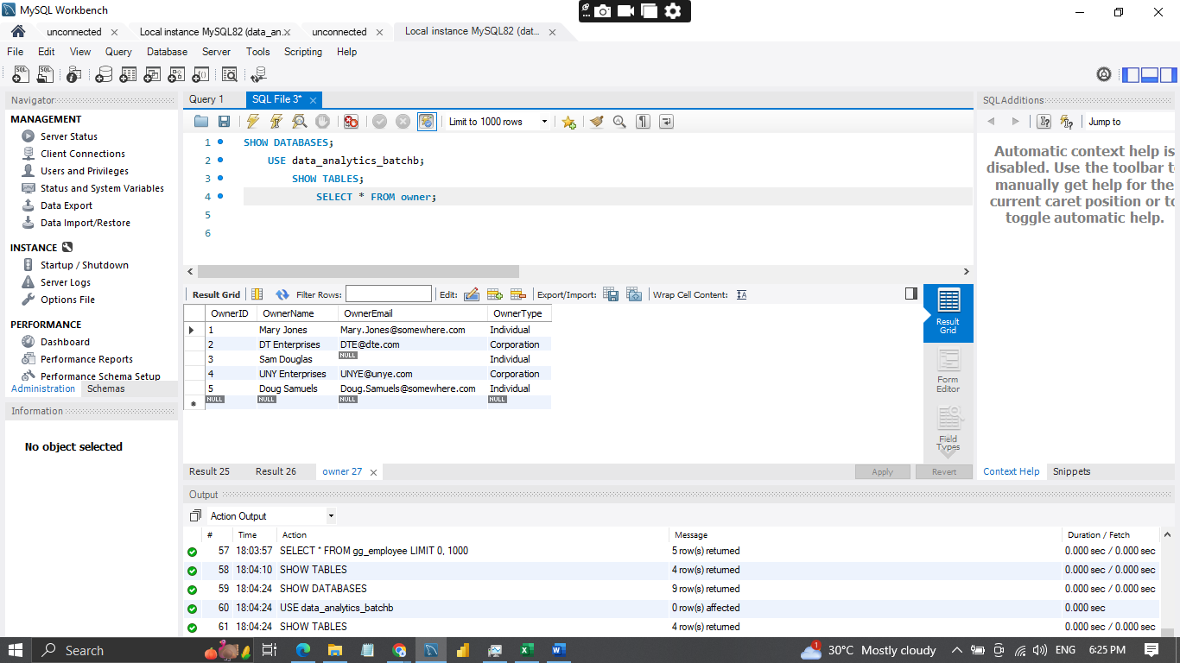

QUESTION 2: Show all OwnerName and OwnerEmail  
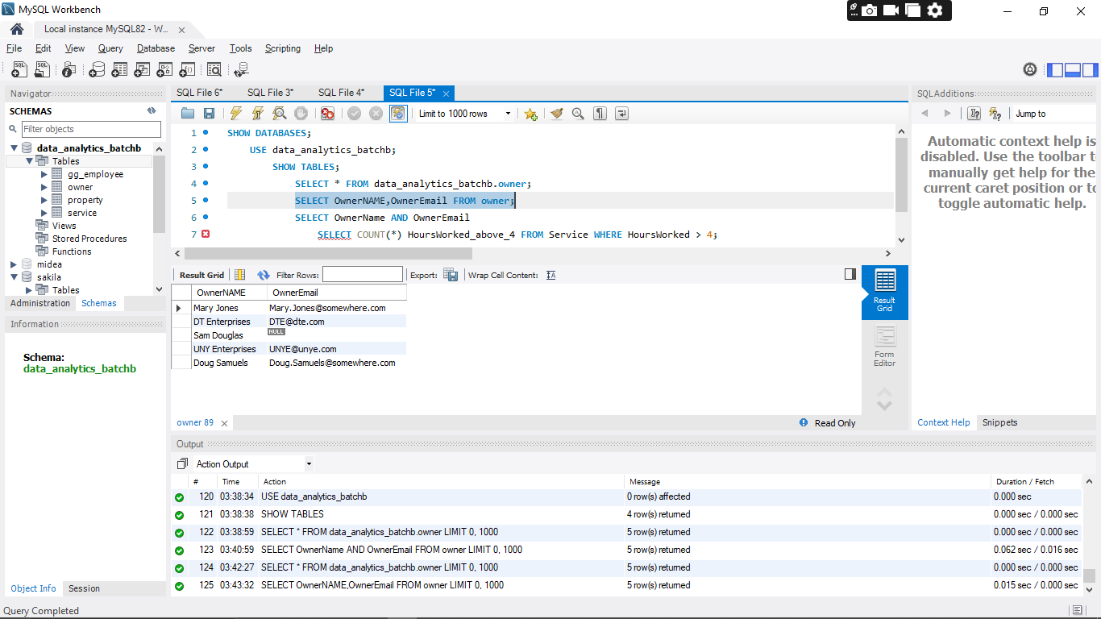

QUESTION 3: Show all OwnerName and OwnerEmail which OwnerType is ‘Corporation’.

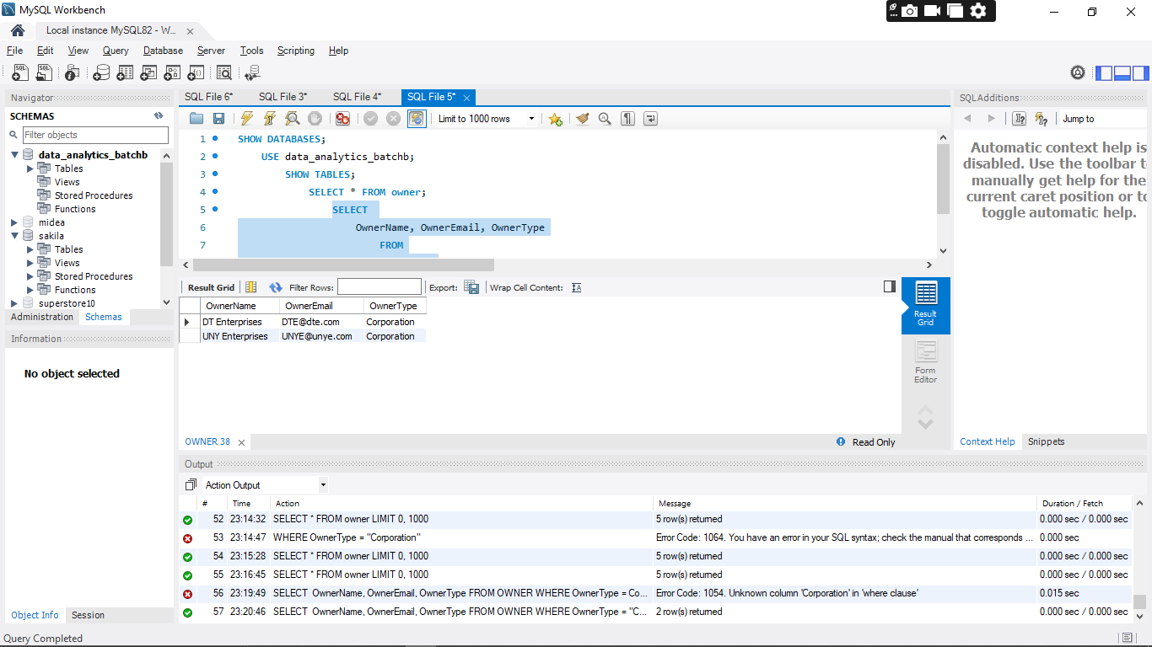

QUESTION 4: Show PropertyID and ServiceDate for all services have HoursWorked more than 4.  
  
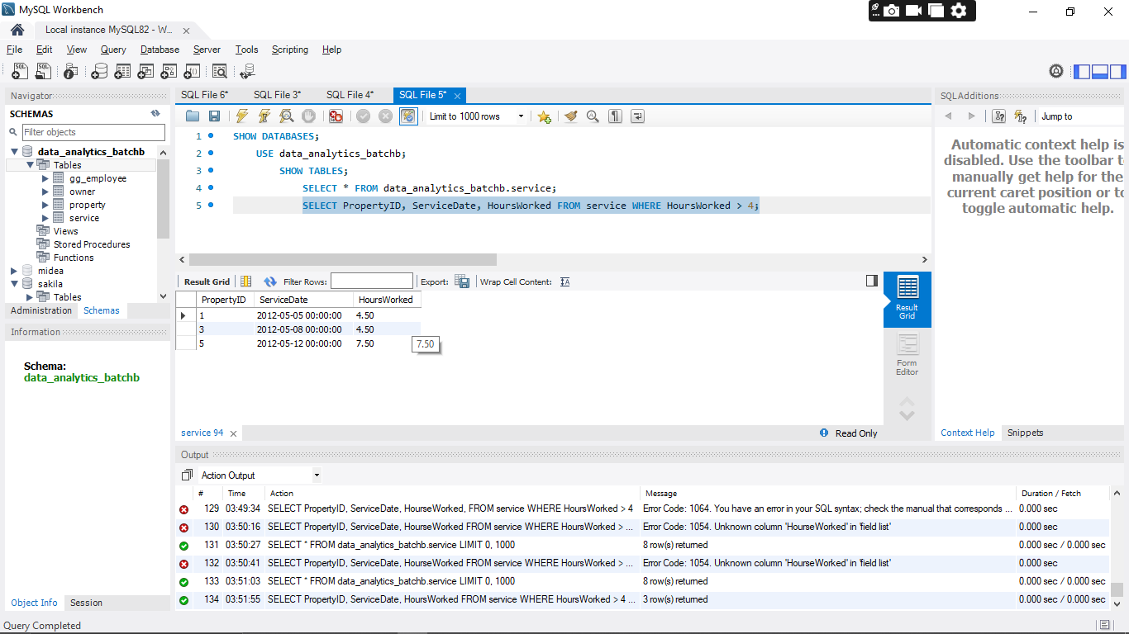

QUESTION 5: Show PropertyID and ServiceDate for all services have HoursWorked between 4 and 6.

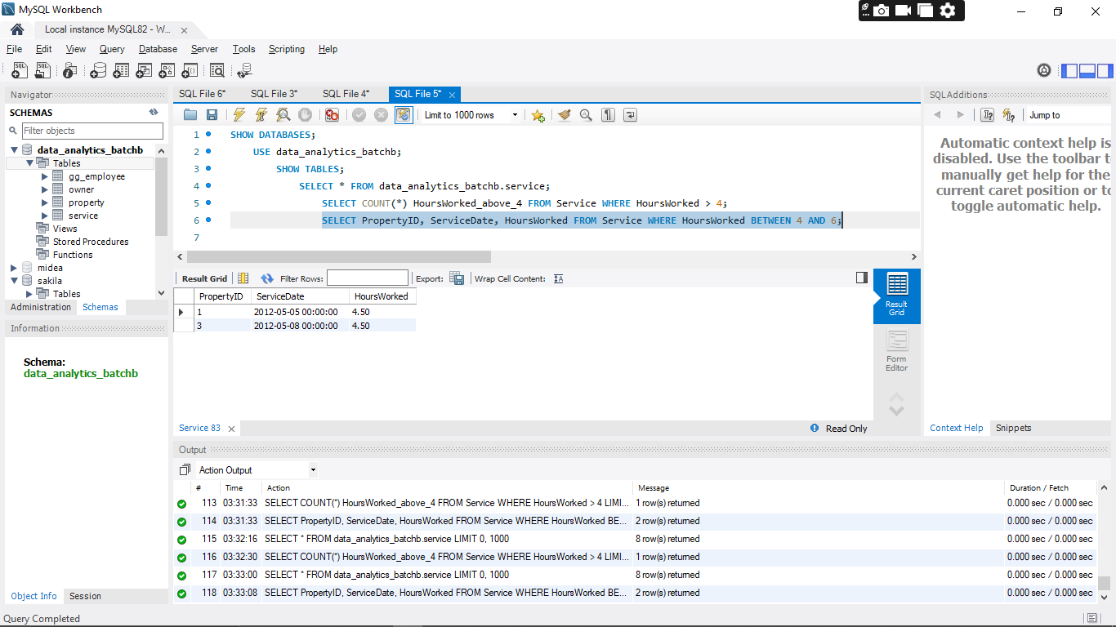

QUESTION 6: Count how many services have HoursWorked more than 4.

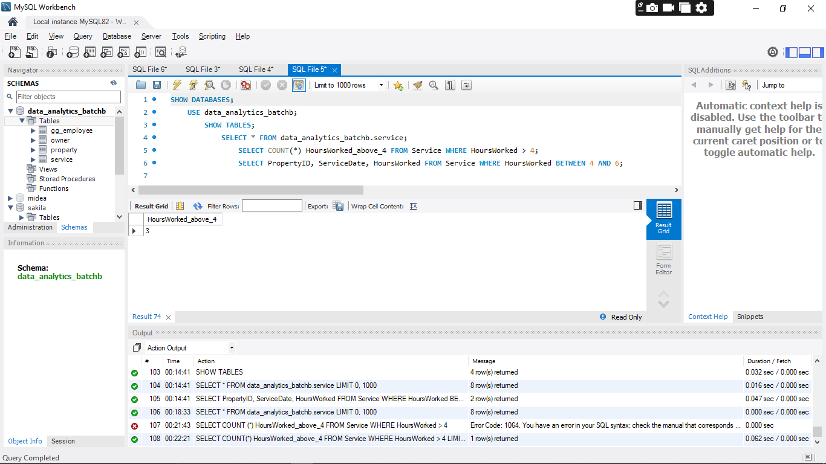

QUESTION 7: Count how many distinct ExperienceLevel in EMPLOYEE table  
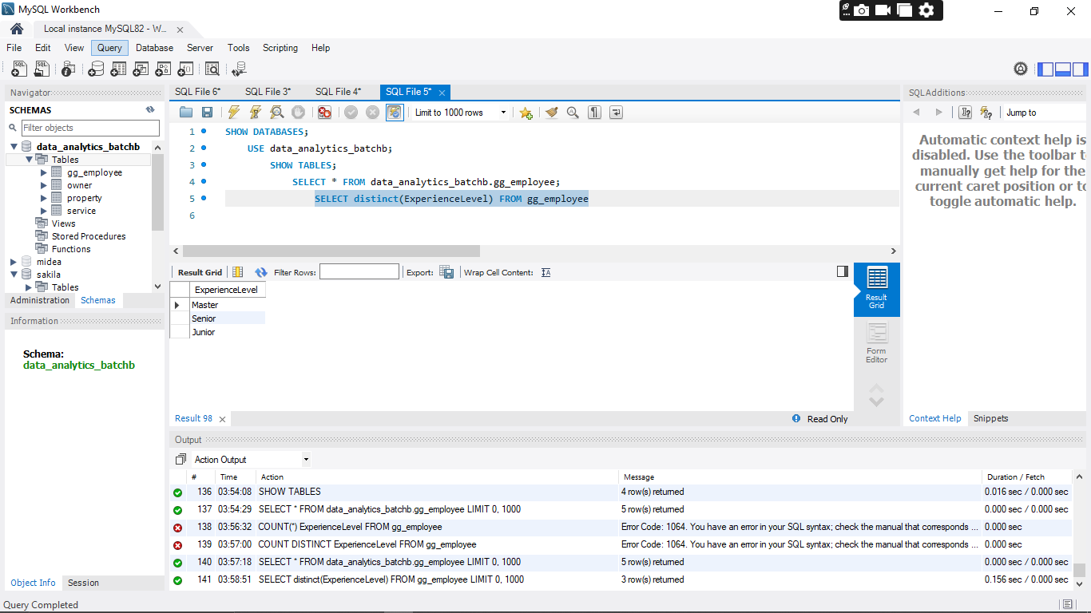

QUESTION 9: Show all properties not in city ‘Seattle’ or ‘Bellevue’  
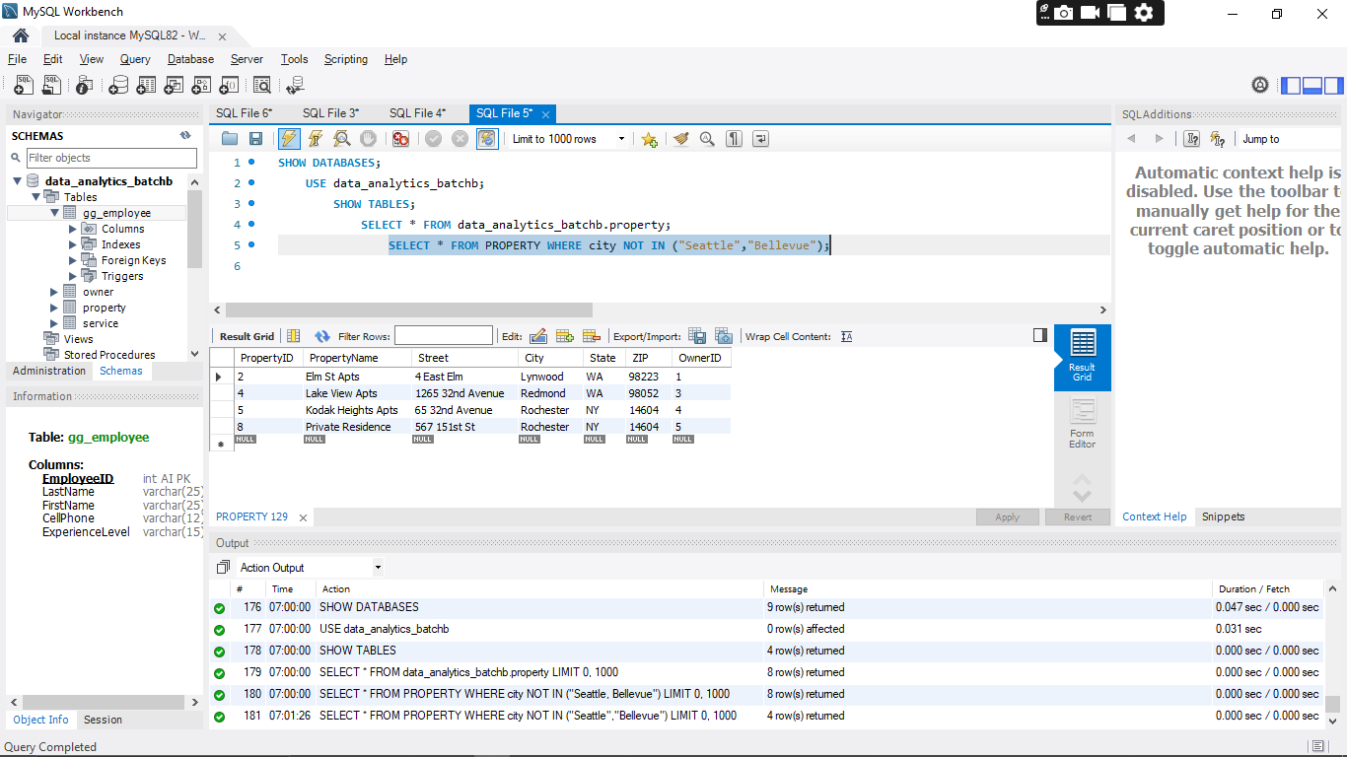

QUESTION 10: Show all properties with PropertyName begins with ‘P’, but the location is not in NY State  
 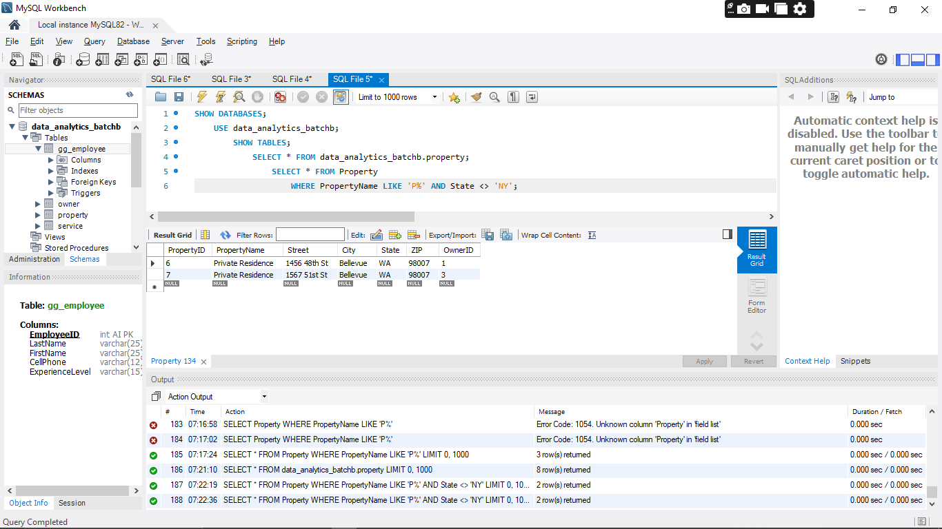

QUESTION 11: Show all the services in descending order of their HoursWorked  
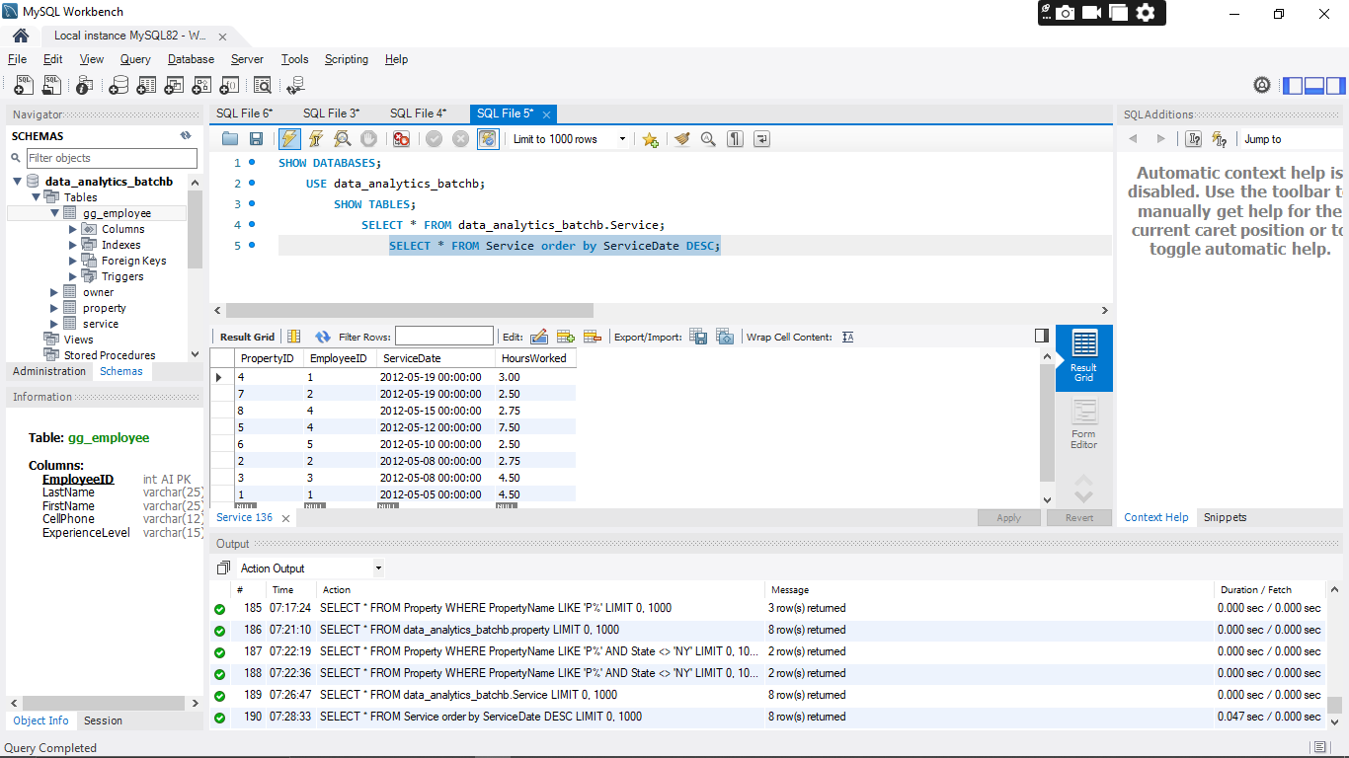

QUESTION 12: Show all the services which HoursWorked is greater than 3 in ascending order of their ServiceDate  
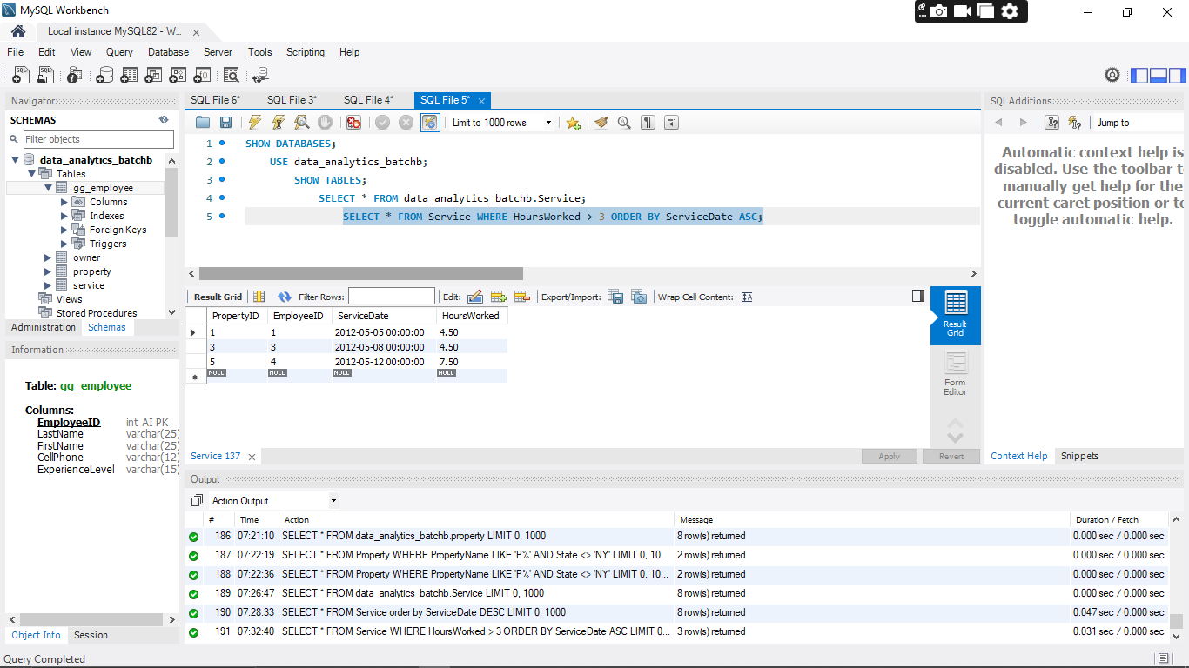

QUESTION 13: Show all owners with Email as NULL.  
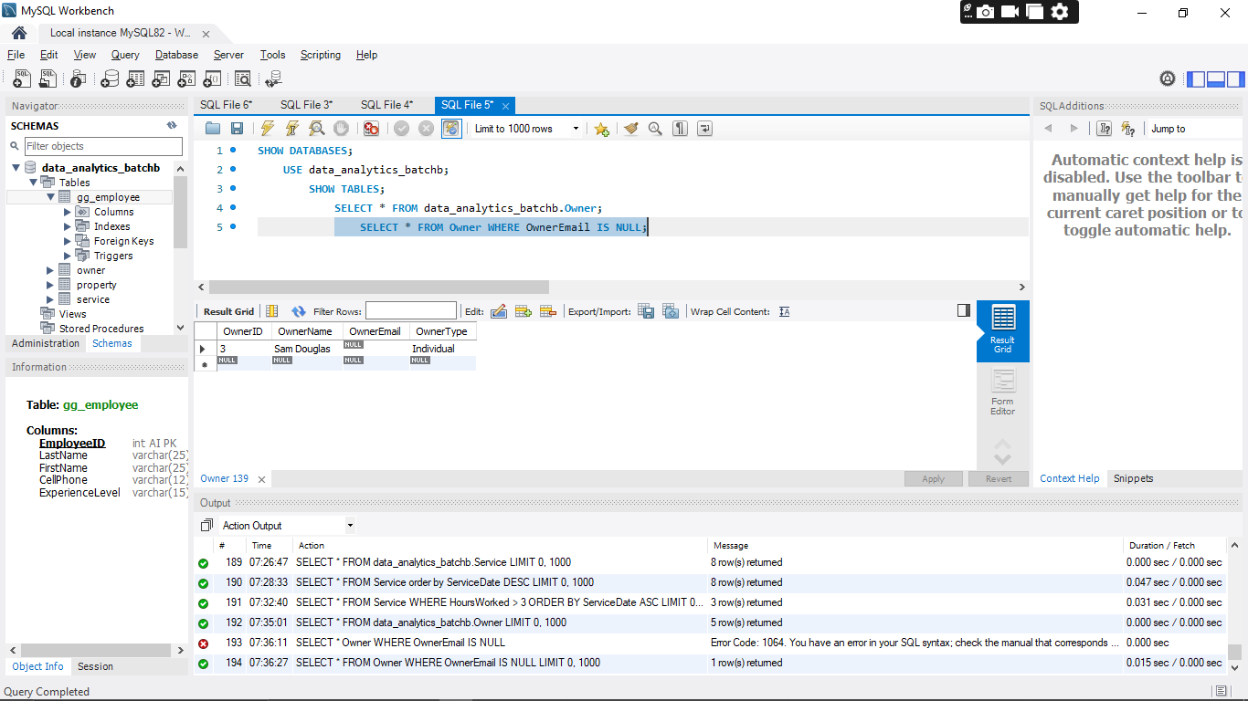

QUESTION 14: Count how many Owners whose Email is not NULL  
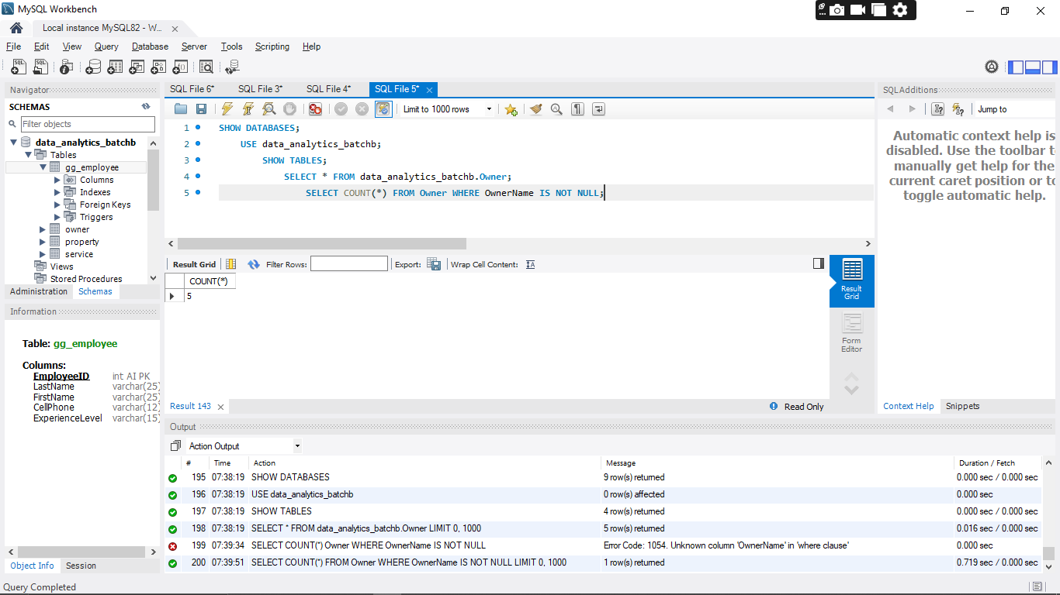

QUESTION 15: Show the sum of Hours Worked in SERVICE  
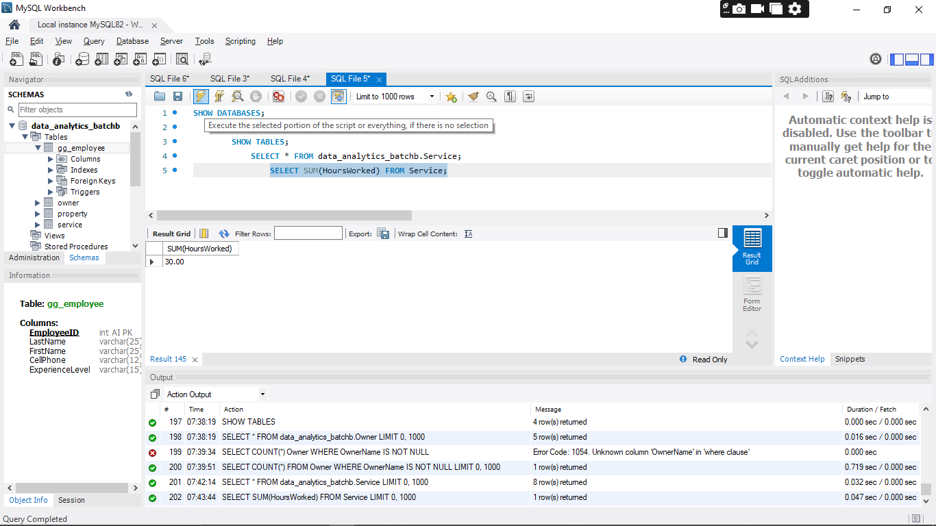

QUESTION 17: Show the names of employees who have worked on a property owned by a corporation.

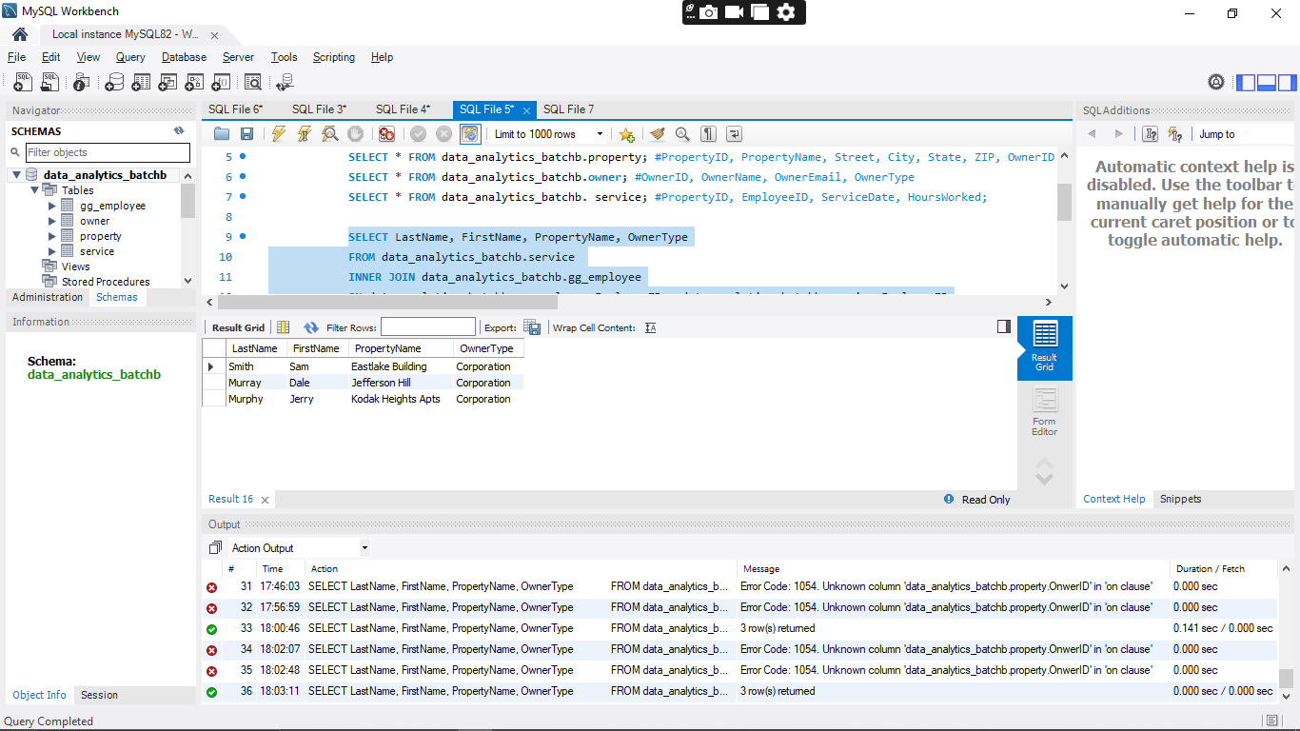

QUESTION 18 Show the names of employees who have worked on a property in New York.

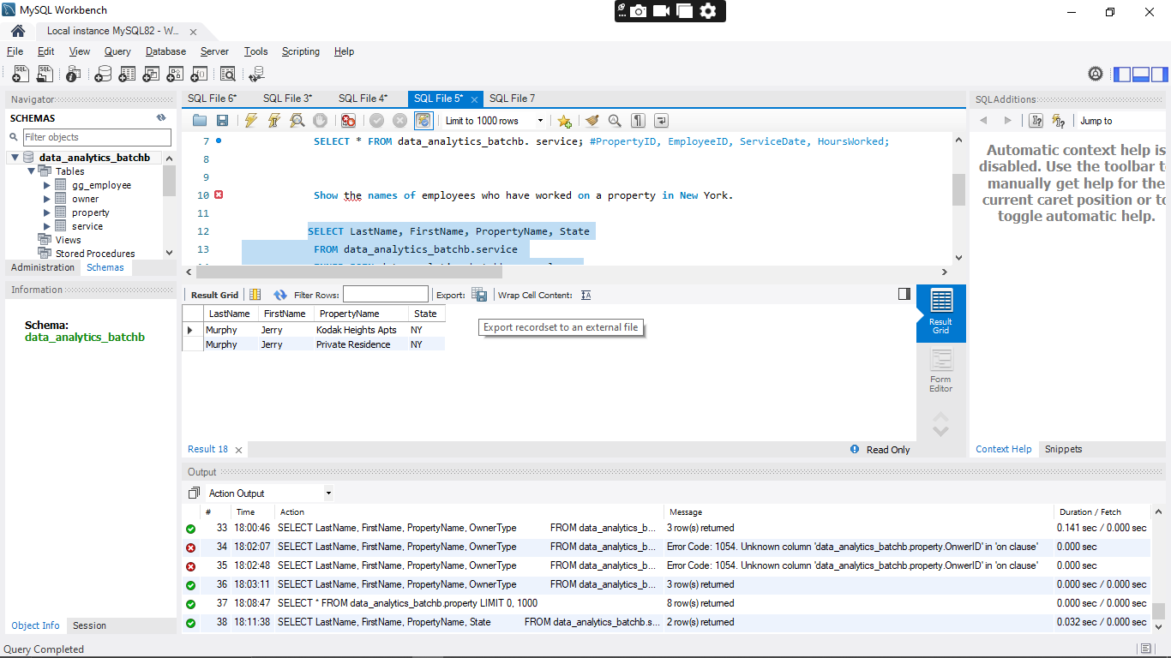

QUESTION 20

